Question 3

To Run Jar Command : hadoop jar Assignment_3.3-Assignment_3.3.jar question_3.OnidaStateMain /user/acadgild/hadoop/television.txt /user/acadgild/hadoop/TotalUnitResult

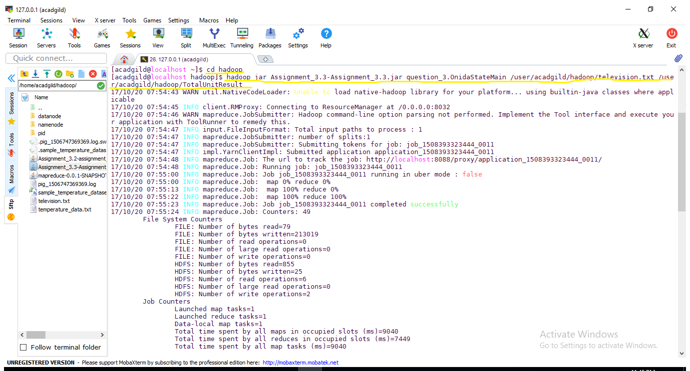

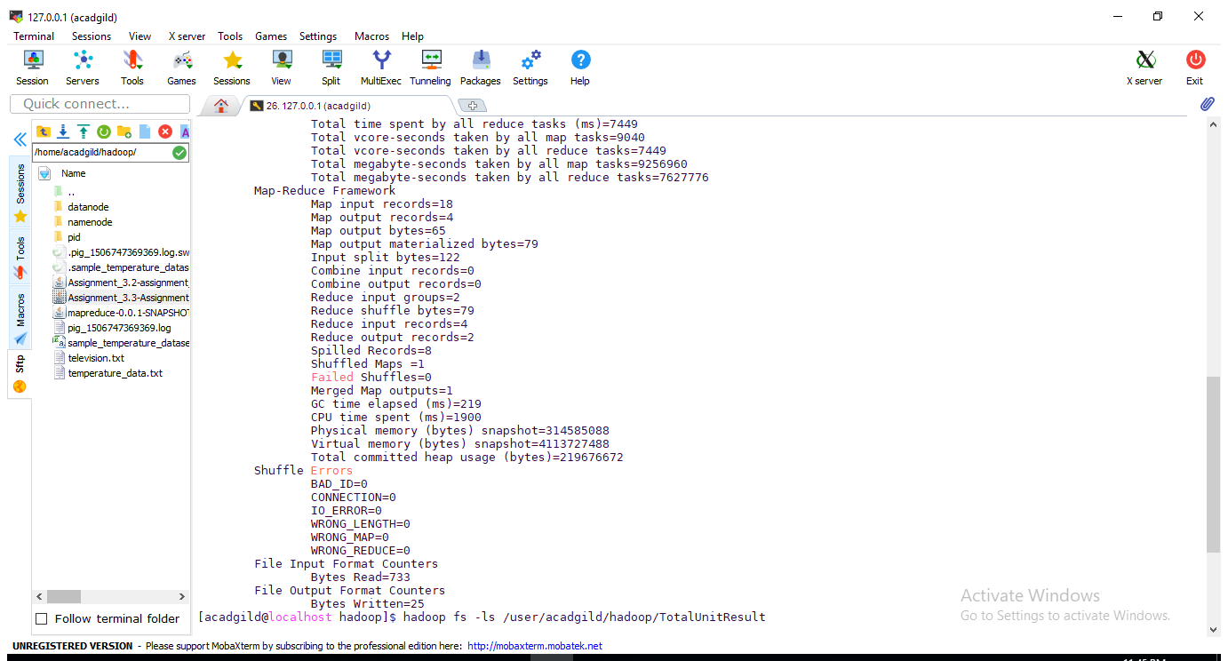

Output

